**Report on**

**Faculty Exchange Program**

**Topic:**  History/ Background of establishment of Supreme Court of India

**Faculty:** Dr Indrani Medhi, Assistant Professor (History)

**Target student:** 3 years LL.B. 2nd Semester

**Date of special class:** 19th February 2025

**Commencement of class:** 2.30 PM to 3.30 PM

**Duration of class:** 1 hour

**Rapporteur:** Dr. Plabita Saikia, Assistant Professor (Law)

**Description:**

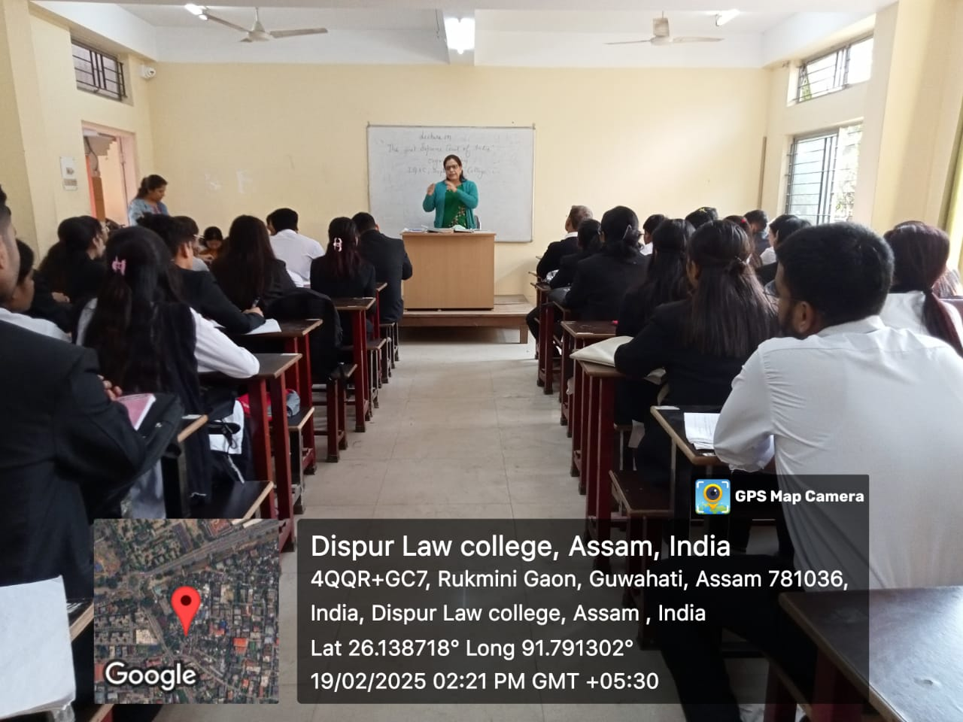

**Img.1: Dr Indrani Medhi, Assistant Professor (History) delivering her lecture**

The faculty started her lecture with the rise of British rule in India and declining local governance gradually. She discussed about several mutinies which took place at that time including Sepoy mutiny (1857), which compel the rulers to form a legal body to control over the rebellion situation and discussed about the Roulette Act along with the establishment of the first Supreme Court in Calcutta during 1774; and to describe it, she mentioned about Regulation Act 1773 also. She said, though the Supreme Court was established in Calcutta at that time, it had conflicts with the supreme council of Bengal over its jurisdiction. That conflicts were continued and therefore, the Indian High Courts Act 1861 was enacted to abolish Supreme Courts and to create high courts for various provinces at Calcutta, Madras and Bombay and also the Sadar Adalats in presidency towns in their respective regions. These new high courts had the distinction of being the highest courts for all cases till the creation of the Federal Court of India under the Government of India Act 1935. The Federal Court had the jurisdiction to solve disputes between provinces and federal states and hear appeals against judgement of the high courts. During the discussion she detailed about Indian first juridical murder (Raja Nand Kumar case) under British colonization during the period of Governor General, Warren Hastings. The Federal Court of India came into being on 1 October 1937 under the Government of India Act, 1935. It functioned until 1950.

The faculty while discussing post-independent period, she said that The Supreme Court of India was established on 26 January 1950 with the coming into force of the Constitution of India. The Supreme Court of India is the apex judicial body under the Constitution of India. The Supreme Court of India came into existence on 28 January 1950. It replaced both the Federal Court of India and the Judicial Committee of the Privy Council, which were then at the apex of the Indian court system.

The Supreme Court initially had its seat at the Chamber of Princes in the parliament building where the previous Federal Court of India sat from 1937 to 1950. In 1958, the Supreme Court moved to its present premises. Originally, the Constitution of India envisaged a supreme court with a chief justice and seven judges; leaving it to Parliament to increase this number.

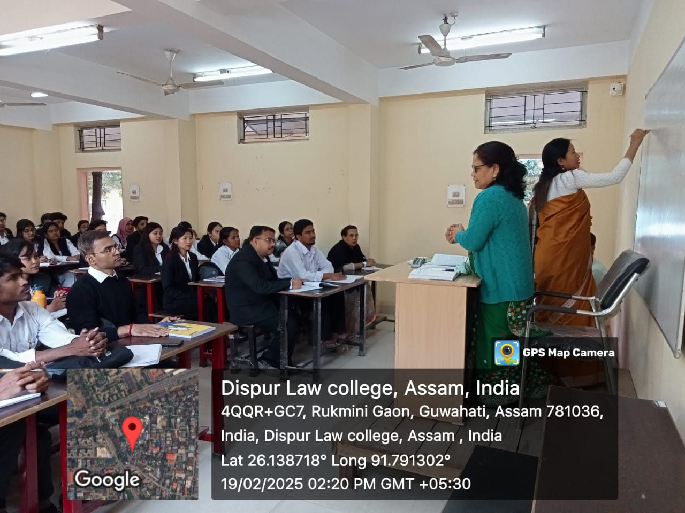

**Img.2: Dr. Swapna M. Deka, Coordinator, IQAC, Dispur Law College delivering**

**her lecture on Constitution**

During the program, Dr. Swapna M. Deka, Coordinator, IQAC, Dispur Law College, Dr. Plabita Saikia, Rapporteur of the Program, Mr. Tanay Paul, and Ms. Nibedita Kalita were present. The program came to an end with vote of thanks by Mr. Tanay Paul, Assistant Professor, Dispur Law College.

The Faculty Exchange Program is an approach for enrichment of knowledge of students and it was successfully done and fruitful outcome was achieved regarding the concerned topic.

Authenticated by:

 

(Dr. Gargi Dutta Paul) (Dr. Swapna Manindranath Deka)

Principal Coordinator, IQAC

Dispur Law College Dispur Law College