**A REPORT ON**

**A SYMPOSIUM ON INTELLECTUAL DISCOURSE ON ENVIRONMENTAL PROTECTION**

**Date: 18th May, 2023**

**Time: 11am onwards**

**Objectives:** **1**. To increase awareness among students about the importance of environment.

**2.** To create awareness about environmental problems among people.

**3**. To motivate the students for participating in environment protection and environmental improvement.

**Guest of Honour: Padma Shri Dr. Jadav Molai Payeng, environmental activist and forestry worker, popularly known as ‘Forest Man of India’.**

**Chief Guest: Prof. Romesh Chandra Borpatra Gohain, Retd Dean and Head of the PG Department of Law, Gauhati University. Retd. Advocate General for the State of Assam, Gauhati High Court.**

Number of Students present: More than 150 nos.

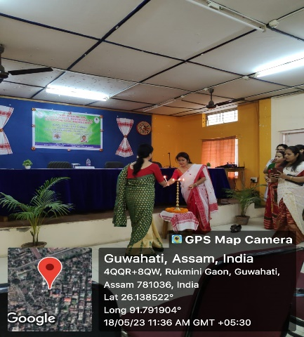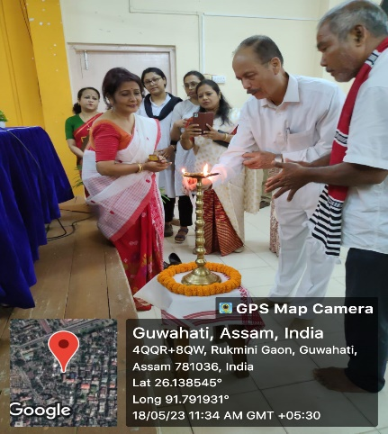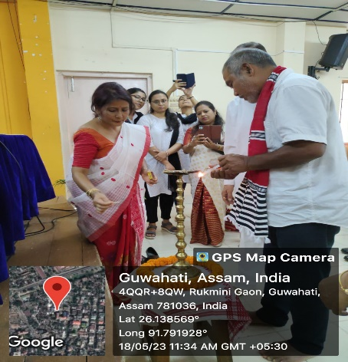

Fig.1: Inauguration of the programme by Principal and IQAC,Coordinator; Chief Guest-Prof. R.C. Barpatra Gohain & Guest of Honour-Padmashree Dr Jadav Payeng

The environment plays an integral role in maintaining the balance of the ecosystem we live in. In order to create awareness about the importance of the environment and its relation with human being, a daylong Symposium on Intellectual Discourse on Environmental Protection was organized in the premises of Dispur Law College on 18 th of May, 2023 under the guidance of Dr. Swapna Manindranath Deka, the Co-coordinator, IQAC, Dispur Law College. The programme began with the plantation of saplings by the Guest of Honour **Padma Shri Dr. Jadav Payeng,** environmental activist and forestry worker, popularly known as ‘Forest Man of India’ and by the Chief Guest **Prof. Romesh Chandra Borpatra Gohain**, retd. Dean and Head of the PG Department of Law, Gauhati University, retd. Advocate General for the State of Assam, Gauhati High Court. Thereafter, the programme has proceeded by the ceremonial lighting of the lamp by the Guest of Honour Padma Shri Dr. Jadav Molai Payeng, Chief Guest Prof. Romesh Chandra Borpatra Gohain, Dr. Gargi Dutta Paul, Vice Principal Dr. Swapna Manindranath Deka and other faculties presen t.

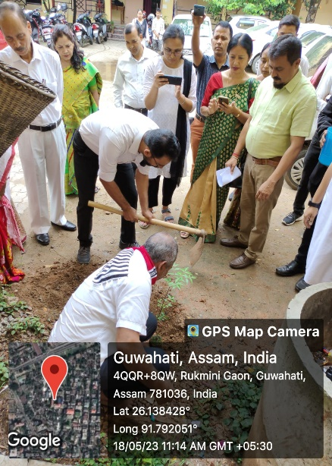 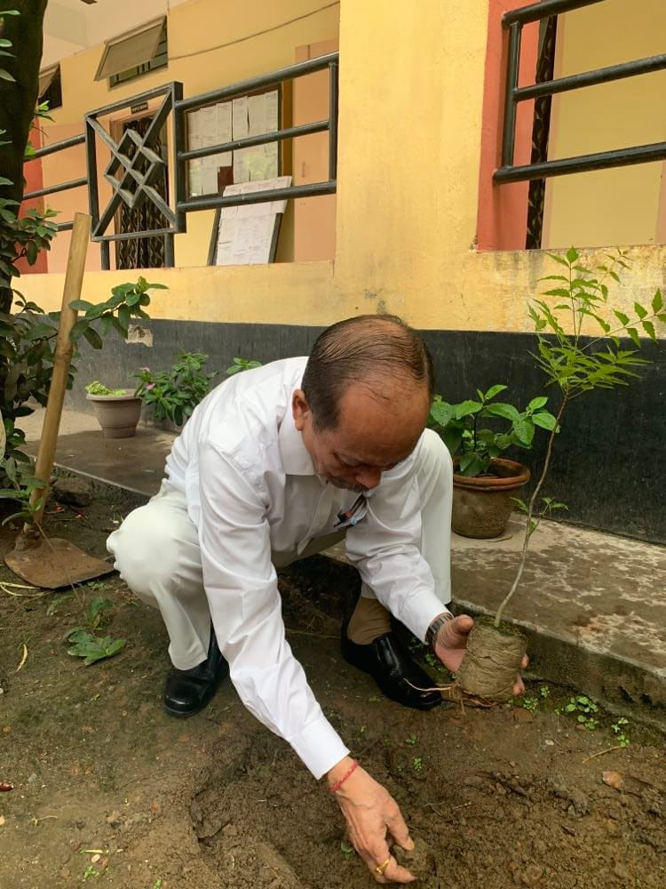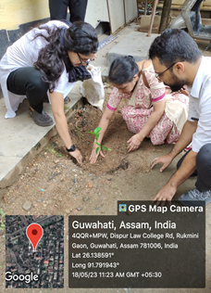

F

Fig.2: Plantation of Neem Saplings and medicinal plant kathana by the invited guests

Speaking on the occasion Prof. Borpatra Gohain highlighted on the relationship between nature and heart. He stressed on producing more and more Jadav Payeng to preserve the Earth for future generation. Though we celebrate Environmental Day spending crores of rupees every year, but we hardly try to maintain it what we have planted. And as students of law we should be give more importance to the practical side instead of relying on theoretical knowledge. The most awaited segment was the speech by Padma Shri Dr. Jadav Molai Payeng whose speech mesmerized all present in the auditorium. He began that nature was above the political, religious and economic boundaries. He recollected how the sight of the dead snakes had a major impact on his life. Even at a young age of 16 he knew that something had to be done, so in 1979 he started planting tree sapling. After so many years his forest covers around1, 390 acres of land. He began by planting bamboo and then moved onto other species. As his forest grew dense, so did the amount of inhabitants. Soon the forest was filled with hundreds of species of birds, deers, rhinos, tigers and herd of elephants. His major turning point in life occurred when a photo journalist Jitu Kalita of an Assamese daily spotted him and covered his story. He also shared his experience in the meeting of the United Nations in front of world communities, where he presented his speech in mother tongue Assamese. After his valuable speech, a short interaction session was held with students. The faculties and the students of the college have immensely benefited by the speech of the Guest of honour and the Chief Guest of the occasion.

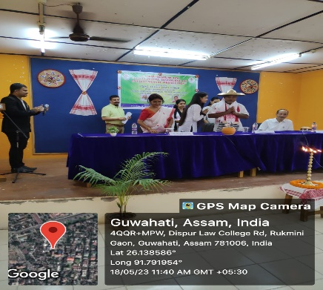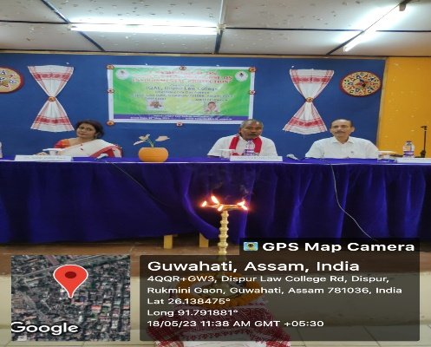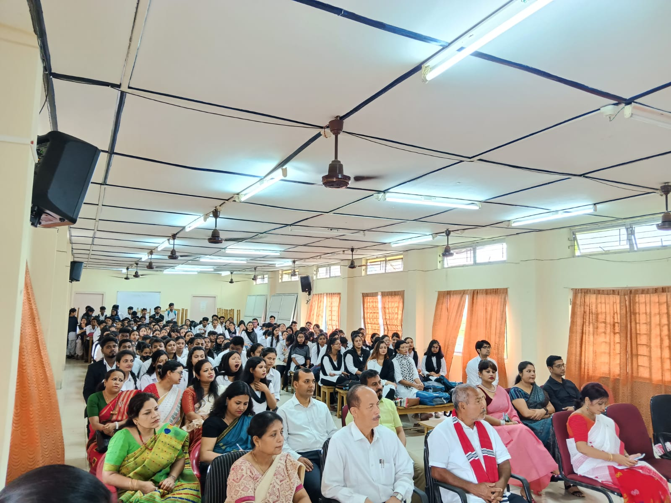

Fig.3: Different sessions of the programme

The vote of thanks of the programme was offered by the Programme Coordinator, Dr. Suranjana Kalita, Assistant Professor of the College.

. 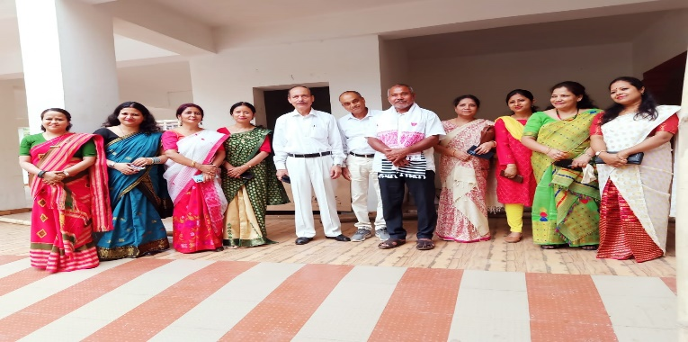 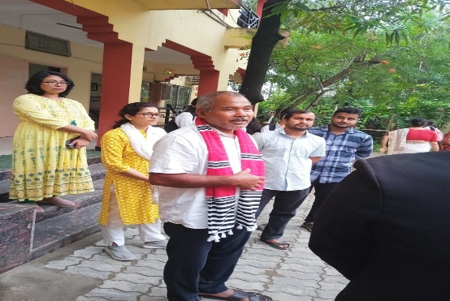 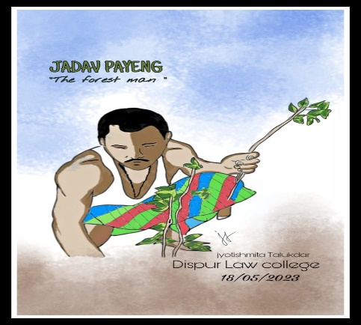 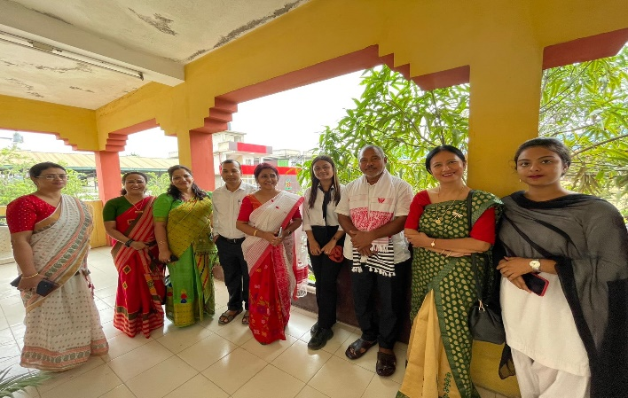

Fig.4: Different captures with the Guest of honour ‘Forest Man of India’

Authenticated by:

(Dr. Gargi Dutta Paul) (Dr. Swapna Manindranath Deka)

Principal Coordinator, IQAC

Dispur Law College Dispur Law College