REPORT ON
EXPERIMENTAL LEARNING THROUGH ENTERTAINMENT AND FUN

Event Date: 22-02-2025
Venue: Dispur Law College
Rapporteur: Dr. Indrani Medhi, Assistant Professor(History), Dispur Law College
Total no of Students: 24
Objective
- Going beyond traditional class room teaching
- To engage students in creative and collaborative learning
- Fostering critical thinking, storytelling and communication skills

Screening movies as part of learning can be valuable and engaging educational tool offering visual and auditory experience to enhance understanding. A flim Chaava (tiger cub) was screened by, History club in association with IQAC Dispur Law college as an academic enrichment activity beyond classroom teaching. The two an hour flim was a historical film action based film about the life and times of Shambhaji the Maratha emperor, his conquests and his resistance against Auranzeb the Mughal emperor and his forces. Carrying forward the defiant approach of his father Chhatrapati Sivaji, he inflicted heavy damage on the pride of Auranzeb, with his unmatched pride and guerrilla tactics before being betrayed by his brother-in-law. The film was acclaimed by several critics. The screening started at around 11.30 am in the conference cum seminar hall. There were around 24 students who attended the event. The film received positive feedback and many were able to see beyond the surface storyline.

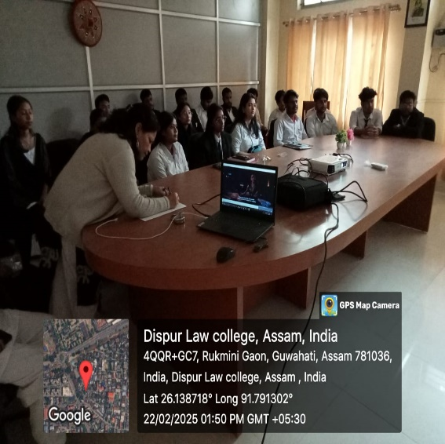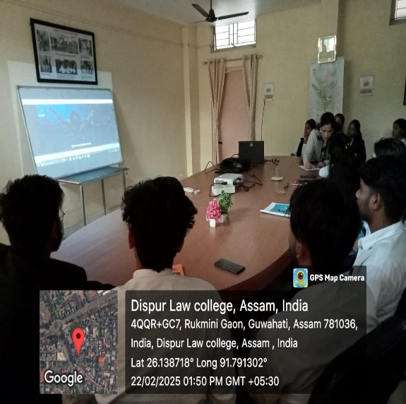
Img.1: Filming of the movie ‘Chaava’

We ended the event at around 2.00 pm and thanked them for attending.

Authenticated by:
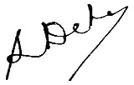
(Dr. Gargi Dutta Paul) (Dr. Swapna Manindranath Deka)
Principal Coordinator, IQAC
Dispur Law College Dispur Law College

